The Mongol Empire
The Mongols were a nomadic tribe of herders who lived in Central Asia. Under their greatest leader, Genghis Khan, they conquered the world's largest empire to date. The Mongols ruled, at one time or another, Russia and parts of Eastern Europe, China, India, and parts of the Middle East.
Mongol Empire
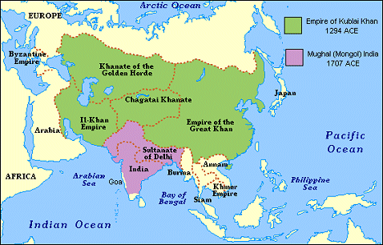
Yet, little of Mongol culture remained after they have left a region. Their power was one of control. During the Pax Mongolia, or Mongol Peace, global trade expanded due to the political stability provided by Mongol rulers. Silk Road trade flourished as goods and ideas, such as gunpowder, porcelain, and the technology of papermaking were traded with the west. The Pax Mongolia was a time of trade and cultural diffusion Little or no Mongol legacy exists today.

